**OSH AUTHORITIES – AUSTRIA**

Source: <https://oshwiki.eu/wiki/OSH_system_at_national_level_-_Austria>

* OSH Infrastructure

Scheme:

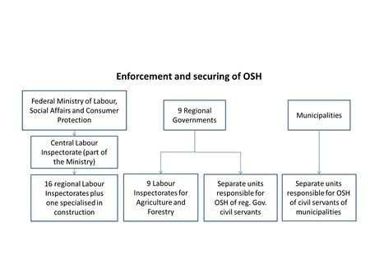

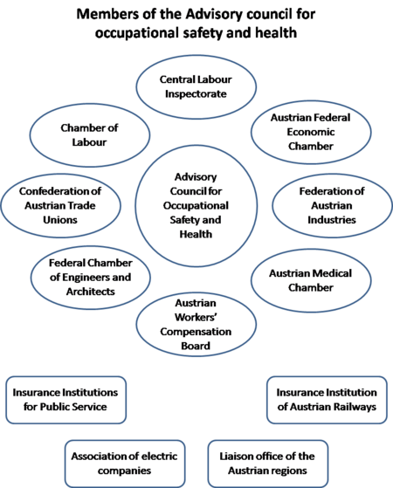

* OSH authorities and inspection services

|  |  |
| --- | --- |
| Name of the Authority | Federal Ministry of Labour, Social Affairs, Health and Consumer Protection (Bundesministerium für Arbeit, Soziales, Gesundheit und Konsumentenschutz) |
| Link | <https://www.sozialministerium.at/siteEN/> |
| Short abstract | The competent authority in OSH matters is the Federal Ministry of Labour, Social Affairs, Health and Consumer Protection. It is responsible for most employment related issues, namely: social security (insurance for pensions and unemployment), industrial relations, labour market policy, labour conditions and inspections, statistics, OSH, and vocational training. |
| Link to OSH wiki | <https://oshwiki.eu/wiki/OSH_system_at_national_level_-_Austria> |

|  |  |
| --- | --- |
| Name of the Authority | Labour inspectorate (Arbeitsinpektion) |
| Link | <https://www.sozialministerium.at/siteEN/Labour_Disabilities/Occupational_Safety_and_Health/Labour_Inspectorate/> |
| Short abstract | The general Labour Inspectorate (Arbeitsinspektion) is by far the largest of those bodies that have been installed to monitor safety and health of the employees. It covers industries, services, the public sector, and transport - following the July 2012 merger with Inspectorate of Transport. It is centralised and acts nationwide through 16 regional departments and one central office. Newly recruited inspectors follow a two-year training programme, with the emphasis on legislation and general OSH principles. At level of the Federal States, nine regional Labour Inspectorates for Agriculture and Forestry are installed. |
| Link to OSH wiki | <https://oshwiki.eu/wiki/OSH_system_at_national_level_-_Austria> |

Internal link to enforcement indicator by MS

* Compensation and insurance bodies

|  |  |
| --- | --- |
| Name of the Body | Austrian Social Insurance for Occupational Risks (Allgemeine Unfallversicherungsanstalt, AUVA) |
| Link | <https://www.auva.at/> |
| Short abstract | The Austrian Social Insurance for Occupational Risks is the largest body in Austria. Like the Labour Inspectorate, AUVA is a centralized national organisation. Founded in 1889 as occupational accident liability insurance for employers, AUVA is responsible for the prevention of occupational accidents and diseases, as well as for the compensation of industrial injuries and accidents, and for rehabilitation. It provides services for more than 3 million employees, plus more than 1 million school children and students. These services include advice, training, expert opinion and information, as well as general assistance on OSH questions, as well as working processes, workplace design, individual protection, and implementing rules, regulations and standards.  Their range of activities includes regional public relations and advertising campaigns, safety training in schools, and ensuring efficient first aid in co-operation with ambulance services. AUVA has a central office in Vienna, four regional offices, and five local offices. It also has six trauma centers and four rehabilitation centers. |
| Link to OSH wiki | <https://oshwiki.eu/wiki/OSH_system_at_national_level_-_Austria> |

|  |  |
| --- | --- |
| Name of the Body | Social Insurance for the Public Sector (Versicherungsanstalt öffentlich Bediensteter, formerly Beamtenversicherungsanstalt, BVA) |
| Link | ­[http://bva.at/portal27/bvaportal/content?content­id=10007.676561&viewmode=content](http://bva.at/portal27/bvaportal/content?contentid=10007.676561&viewmode=content) |
| Short abstract | The Social Insurance for the Public Sector was originally the social insurance body (workplace accidents, health insurance and pensions fund) for public servants only. Since 2004 it has become also workplace accident and health insurance body for Austrian university staff. It also insures its own workers and voluntary probation officers against workplace accidents. |
| Link to OSH wiki | <https://oshwiki.eu/wiki/OSH_system_at_national_level_-_Austria> |

|  |  |
| --- | --- |
| Name of the Body | The Social Insurance for Railway and Mining Industry (Versicherungsanstalt für Eisenbahnen und Bergbau, VAEB) |
| Link | <https://www.vaeb.at> |
| Short abstract | The Social Insurance for Railway and Mining Industry is the workplace accident insurance body for workers of the railway, public transport and the cable-car sector. The workplace accident insurance of mining workers is, however, provided by AUVA. |
| Link to OSH wiki | <https://oshwiki.eu/wiki/OSH_system_at_national_level_-_Austria> |

|  |  |
| --- | --- |
| Name of the Body | The Social Insurance Institution for Farmers (Sozialversicherungsanstalt der Bauern, SVB) |
| Link | <http://www.svb.at/> |
| Short abstract | The Social Insurance Institution for Farmers is the body that provides workplace accident insurance, health insurance and pensions fund for the agricultural and forestry sector (including employers and self-employed farmers). It also grants benefits to help family members and dependent workers. It was founded on the basis of the Law on Social Insurance in the Agricultural Sector (Bauernsozialversicherungsgesetz) |
| Link to OSH wiki | <https://oshwiki.eu/wiki/OSH_system_at_national_level_-_Austria> |

* Research institutes

|  |  |
| --- | --- |
| Name of the Institute | Safety Technology Testing and Research Centre  Ludwig Boltzmann Institute for Experimental and Clinical Traumatology |
| Link | <http://trauma.lbg.ac.at/> |
| Short abstract | The Austrian Workers' Compensation Board/Austrian Social Insurance for Occupational Risks (AUVA) Center for Traumatology Research encompasses the AUVA Institute for Traumatology Research and, as of 1980, the Ludwig Boltzmann Institute for Experimental and Clinical Traumatology (Ludwig Boltzmann Society), receiving additional support from the Trauma Care Consult since 1998. The Ludwig Boltzmann Institute for Experimental and Clinical Traumatology has been the core of the Austrian Cluster for Tissue Regeneration since 2006 which was further enlarged in 2013/2014. |
| Link to OSH wiki | <https://oshwiki.eu/wiki/OSH_system_at_national_level_-_Austria> |

|  |  |
| --- | --- |
| Name of the Institute | Austrian Academy of Occupational Medicine and Prevention |
| Link | <http://www.aamp.at> |
| Short abstract | The AAMP is the most important Austrian institution for the education and training of occupational physicians, occupational health professionals and other persons interested in occupational medicine or work-related prevention. |
| Link to OSH wiki | <https://oshwiki.eu/wiki/OSH_system_at_national_level_-_Austria> |

* Prevention institutes

|  |  |
| --- | --- |
| Name of the Institute | Austrian Social Insurance for Occupational Risks (Allgemeine Unfallversicherungsanstalt, AUVA) |
| Link | <https://www.auva.at/> |
| Short abstract | Their range of activities includes regional public relations and advertising campaigns, safety training in schools, and ensuring efficient first aid in co-operation with ambulance services. AUVA has a central office in Vienna, four regional offices, and five local offices. It also has six trauma centers and four rehabilitation centers. |
| Link to OSH wiki | <https://oshwiki.eu/wiki/OSH_system_at_national_level_-_Austria> |

* Other OSH services

|  |  |
| --- | --- |
| Name of the service | Organisation of Austrian Safety Specialists (Verband österreichischer Sicherheits-Experten – VÖSI) |
| Link | <http://www.voesi.at/> |
| Short abstract | Since 1977, the VÖSI has been representing the interests of the Austrian safety experts (SFK) as well as all experts working in the areas of safety, health protection as well as environmental and fire protection at work.  Originally thought to represent the interests of security engineers - hence the name VÖSI - the association has over the years become a platform for experts from above. |
| Link to OSH wiki | <https://oshwiki.eu/wiki/OSH_system_at_national_level_-_Austria> |

|  |  |
| --- | --- |
| Name of the service | Austrian Association for Promoting Occupational Safety (Österreichischer Verband zur Förderung der Arbeitssicherheit, VAS) |
| Link | <http://www.vas.at/> |
| Short abstract | The Austrian Association for the Safety of Occupational Safety (VAS) is an association of producers and specialist retailers of occupational safety products. The aim is to contribute to the improvement of occupational safety in Austria through optimal information provision. As a focus of its activity, the Association of Occupational Safety therefore sees the coordinated and factual information in the field of personal protection. The Occupational Safety Association was founded in 1990 and today has 30 members |
| Link to OSH wiki | <https://oshwiki.eu/wiki/OSH_system_at_national_level_-_Austria> |

* Standardization bodies

|  |  |
| --- | --- |
| Name of the Body | Austrian Standards International |
| Link | <https://www.austrian-standards.at> |
| Short abstract | Austrian Standards stands for Austrian Standards International (formerly Österreichisches Normungsinstitut), a non-profit service organization (association), as well as for its subsidiary Austrian Standards plus GmbH founded in 2008 and Austrian Standards Operations GmbH founded in 2018, a 100% subsidiary of Austrian Standards plus GmbH |
| Link to OSH wiki | <https://oshwiki.eu/wiki/OSH_system_at_national_level_-_Austria> |